How to Disable SIP ALG on TP-Link ADSL modem router
Suitable for: TD-8816, TD-8817, TD-8840T, TD-8841T, TD-W8101G, TD-W8901G
For the VOIP application, sometimes the ISP will ask you to disable SIP ALG on your modem router. Please refer to the following steps to do the configuration.
Step 1 Press the Windows Logo Key +"R" Key on the Keyboard at the same time or click on Start button->Run to open Run program.

Step 2 Type in cmd in the open bar and click OK.
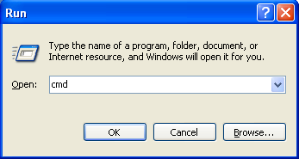
NOTE: In Windows 7,you can also just type cmd in the search bar and
press Enter instead of above two steps .
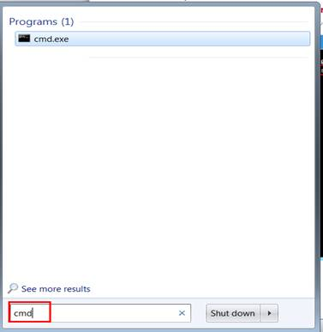

Step 3 Type in "telnet 192.168.1.1" (192.168.1.1 is the default IP Address of the modem router, if you have changed it, please type in the matched IP) and press Enter.
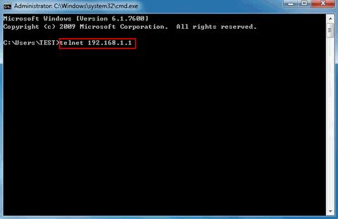
NOTE:In Win7 or Vista, the telnet command may not be enabled by default, please click on Start button->Control Panel->Programs-> Programs And Features->Turn Windows features on or off,then Check Telnet Client and hit OK to enable telnet command.

Step 4 In the telnet page, type in the password for the modem router (default is admin) and press Enter.

Step 5 Type in command ip nat service sip sw off.If SIP ALG is disabled successfully, it will show Nat Sip v2 switch off!
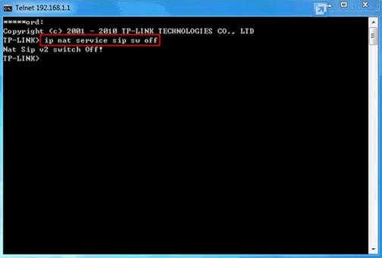
NOTE：
All of the above settings are temporary. Once you restart or reset the modem, the SIP ALG will be turned back on.

